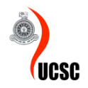
ENH3101/EN3001 – Industrial Placement 2021
Monthly Progress Report
Progress Report
Report Number  (Tick with a √) | √ |  | 2 | 3 | 4 | 5 |  | 6
Student Name | H.P.A.L Pathirana
Index Number/ Registration Number | 18020526 / 2018is052
Company Name | Pristine solutions (pvt) Ltd
Internship Commencement Date | 1/10/2021
Reporting Period / Month | 1/10/2021 – 31/10/2021
Work Carried out during the reporting period
Week | Brief Description of the Work Carried Out
1 | This week only includes with one day (1 of October). Participated to the welcome session which held on the first day at Pristine Solutions.  Participated in 2 General meetings which were held targeting the all-internship employee. (Session including the rules and regulation which are maintained inside the Company)  Set Up Email accounts.  Those are the things basically done on the week  Note - 1st of October is a Friday and this week included only one working day.
2 | Done a document study about the current ongoing project inside the PDS team (Project Development and Strategy) I studies the SFA (Sales Force Automation), MDA, Tea One, Currier Management System.  Studied document related to the Norwood Fashion.  - Fabric cutting Process System  - Apparel Process  - Manufacturing Order Process  Participated to an internal meeting with Mr. Kanishaka to gathered the knowledge about past activated which has done related to the Norwood Fashion.  Studied the external source tutorial related to the SAP Business One. Done research finding to study the SAP One software. Studies basically covered the following areas including several knowledge sharing session.  - MRP (Material Requirement Planning)  - Production process  - Resources  - Create resources  - Linking with BOM and production  Had Internal meeting with Ms. Sathsarani, Ms. Dilini, Mr. Kanishka, Shifna to dicuss about the Norwood Fashion new requirements.  Created separated meeting minutes for each meetings held to discuss about the Norwood Fashion. Ms., Sathsarani, Ms. Dilini both shared their experience in gathering requiremts and make us ready to follow up a real requirement gathering sessions.
3 | Worked in Studying the SAP Business One. Worked corporately with the MR. Hirantha to set up the SAP Business One. Did a follow up on Norwood documentations which are created by the Ms. Sathsarani.  Had Internal meeting to discus about the gathered knowledge about the Norwood. From my end I shared the information and the data I have gathered from my side after referring to the documents. Apart from the basically discuss belove points  - Discuss where it needs to start the requirement gatherings.  - Discuss about the participant  - Shared the knowledge about the Norwood which has gathered by previous meetings with the members  Continue in working on the company study. Updated the previous document by including the points that I have gathered  As we readied, we face to the first client meeting related to Norwood Fashion. The meeting was scheduled to gather clients’ requirements. Mr. Amila was there to represent the Norwood Fashion and Ms. Dilini, Mr. Kanishaa, Miss Shifna and my self-participated there. As we discussed we gathered requirement via the online conducted the client meeting.  After meeting as we are allowed to record the session, I listened to that recording again to verify that where I have missed to gather information related to the Clients meeting. Update the document with new points and create a report to get the approval from the supervisor.
4 | This week basically work on creating the report the on Norwood fashion requiremts gathered session. Had several internal meetings and discussed about the things and data which are collected by each. Worked in identifying the requirements and validate them internally by discuss them with Ms. Sathsarani, and Ms. Dilini. According to the created the report created the work flow diagram. Had 2 sperate meeting to validate the workflow diagram. One basic feedback that we are asked to include the gathered requiremts within the created workflow diagrams.
5 | In this week basically work in “Araliya Email scheduling system”. To address that requirement in Araliya Land I had to followed up the earlier document which has done by Ms. Dilini. After sharing those documents with me I referred them and had an internal meeting with the MS. Dilini to get more knowledge about her documents.  After getting know about the current stage of the pre proposed system. I worked in completing that project before it has next meeting with the Araliya Land client. Client had requested to check the system that we had under proposing solutions.  So, this worked I started to work on Ms. Dilini’s proposed email scheduling system. I basically worked on creating protype for that proposed solution by improving the places where it need to be improved.  While working with the prototype had several internal meetings with Ms. Dilini to evaluate the prototype progress I have done on that point. I worked to improve the project on her feedbacks  This week basically worked in creating full “Email scheduling system”’ protype and get readying to the meeting with “Araiya Land” email scheduling system.

Problems Encountered
None
Planned work that were unable to carry out during the reporting period with reasons
None
To be filled by the Placement Officer/Manager/Supervisor
Name of the placement officer/manager |  | Akila Sajith Kumar
Contact Number of the placement officer/ Manager |  | 0760969524
Leave Record |  | No of Approved Leave  No of unapproved Leave |  |  |  |  | Days
Student has done |  |  |  |  |  |  | Work for the reporting period
   | More than enough | x | Sufficient |  | Not Enough |  | No
Student is progressing
  x | Well ahead |  | Sufficiently |  | Not Enough
Further Comments
(if any)
 |  |  |  | 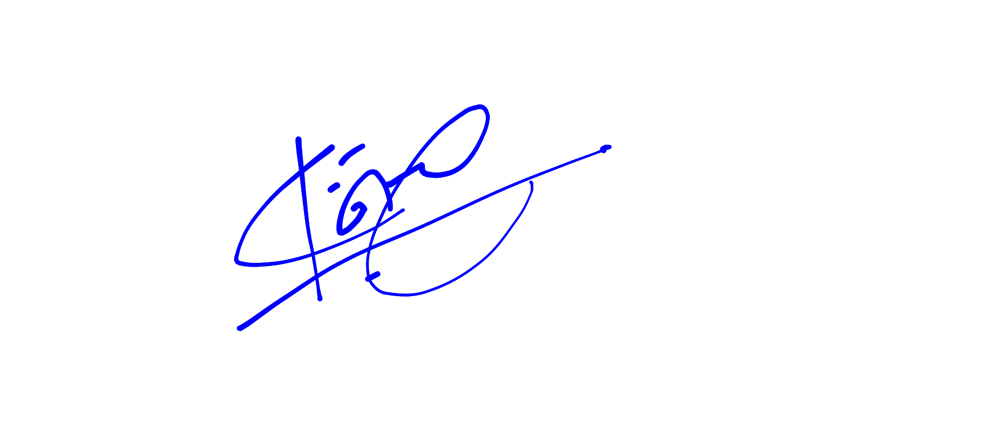
Student’s Signature |  |  |  | Placement Officer/Supervisor’s Signature

Monthly progress report should be approved and signed by the Placement Supervisor at the end of each month. This should be attached to the final internship report that should be submitted to the UCSC at the end of the Internship. Please note that the intern should at least submit five (5) monthly progress reports at the end of their internship.

